Multimorbidity Clustering and Survival Analysis using MIMIC IV
Author: Dr.Aishwarya Bhondge
Affiliation: Masters in Health Informatics, College of Public Health, George Mason University

Keywords: Multimorbidity, Electronic Health Records (EHR), Machine Learning, Survival Analysis, K-means Clustering, Mortality Prediction

Abstract
Objective: To identify clinically meaningful multimorbidity clusters and evaluate their association with patient mortality using both survival analysis and machine learning approaches.
Materials and Methods:
We analysed 431,231 adult patients from the MIMIC dataset, including demographics, comorbidities, and laboratory measurements. Multimorbidity clusters were derived using K-means clustering on standardized clinical features. Survival outcomes were assessed with Kaplan-Meier and Cox proportional hazards models. Mortality prediction was evaluated using Random Forest and XG Boost classifiers, with performance metrics including accuracy, precision, recall, F1-score, and ROC-AUC. Feature importance was examined to identify key predictors.
Results:
Four distinct multimorbidity clusters were identified. Kaplan-Meier survival curves showed significant differences in survival probability between clusters. Cox regression revealed that cluster membership, age, kidney function (creatinine, BUN), and cardiovascular comorbidities were significant predictors of mortality. Random Forest and XG Boost classifiers achieved ROC-AUCs of 0.76 with renal function, age, and cluster membership among the top predictive features.
Conclusion:
Multimorbidity clusters capture clinically meaningful patterns associated with mortality. Combining clustering with supervised machine learning enhances risk stratification in hospitalized patients.

Introduction
Hospitalized patients increasingly present with multiple chronic conditions, a phenomenon known as multimorbidity, which complicates clinical care and is associated with higher morbidity, mortality, and healthcare utilization (Williams et al., 2022). Traditional risk prediction models that focus on individual diseases often fail to capture the complex interactions between coexisting conditions, limiting their ability to accurately stratify patient risk (Pasea et al., 2023).
Electronic health records (EHRs) provide a rich source of longitudinal clinical data, enabling the identification of multimorbidity patterns and the development of more sophisticated predictive models (Prigge et al., 2025). Prior work has shown that real-world EHR data can be leveraged to predict adverse outcomes, including mortality and disease-specific complications, while accounting for the interplay of multiple comorbidities (Bandyopadhyay et al., 2024).
Despite these advances, there remains a need to integrate unsupervised and supervised learning approaches to uncover clinically meaningful multimorbidity clusters and evaluate their association with outcomes. Clustering techniques can reveal latent patient subgroups with distinct comorbidity profiles, while machine learning models can leverage these clusters alongside clinical features to improve mortality prediction.
This study aims to combine these approaches by identifying multimorbidity clusters in a large EHR dataset and assessing their relationship with in-hospital mortality using both survival analysis and machine learning models. By doing so, we seek to enhance risk stratification, provide actionable insights for clinical decision-making, and highlight high-risk patient subgroups that may benefit from targeted interventions.

Materials and Methods
- Data Sources
Data were obtained from the MIMIC IV database, including:
- Patients Table: demographics, date of death
- Admissions Table: admission and discharge times, the first hospital admission was included for patients with multiple stays
- Diagnoses: ICD codes for chronic conditions
- Laboratory Events: selected labs including creatinine, BUN, haemoglobin, glucose, HbA1c, and urine output
- Feature Engineering
- Demographics: Age, gender
- Comorbidities: Hypertension, CKD, heart failure, coronary artery disease, COPD, liver disease, cancer, diabetes (based on ICD codes)
- Labs: First recorded value during admission or median imputation for missing data
- Urine Output: 24-hour sum
- Multimorbidity Clustering
- Features: age, gender, labs, comorbidities
- Preprocessing: numeric conversion, median imputation, zero-variance removal, and standard scaling
- Clustering: K-means with k=4 clusters; cluster profiles analysed using medians
- Visualization: PCA projection of clusters
- Survival Analysis
- Kaplan-Meier: Survival curves stratified by cluster
- Cox Proportional Hazards Model: Evaluated the effect of clusters and clinical features on mortality; hazard ratios (HR) with 95% confidence intervals reported
- Machine Learning Mortality Prediction
- Models: Random Forest and XG Boost classifiers
- Features: Cluster membership + clinical features
- Train-Test Split: 80:20 stratified by outcome
- Metrics: Accuracy, precision, recall, F1-score, ROC-AUC
- Feature Importance: Extracted from tree-based models

Results
- Cohort characteristics:
Total patients: 180386
Mean age: 56.9
Female (%): 52.2
Median follow-up (days): 3
Overall mortality (%): 24.5

- Cluster Analysis
Cluster | Summary | Interpretation
0 | Younger, mostly female, mild HTN | Low risk cardiometabolic profile
1 | Older male, HTN + diabetes | Medium-risk metabolic multimorbidity, Diabetes is the main comorbidity.
2 | HTN + severely elevated creatinine/BUN | High-risk kidney dysfunction phenotype (CKD/AKI), Likely has acute or chronic kidney injury; the highest mortality risk among clusters.
3 | Older male with COPD | Respiratory multimorbidity, likely frail

Figure 1: Elbow method and Silhouette score
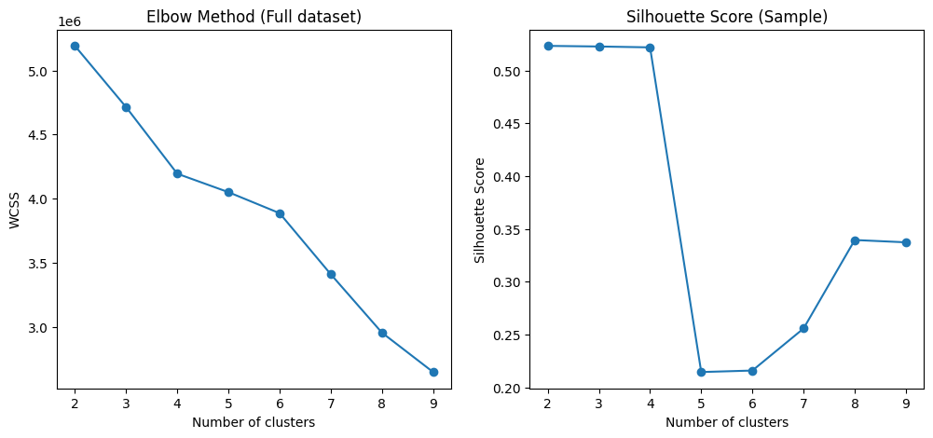
Figure 2: PCA projection of K-means clusters (sample n=20,000)
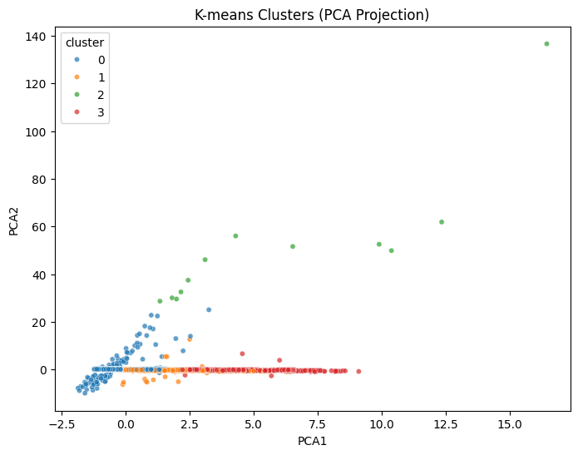
Figure 3: Survival by Multimorbidity Cluster
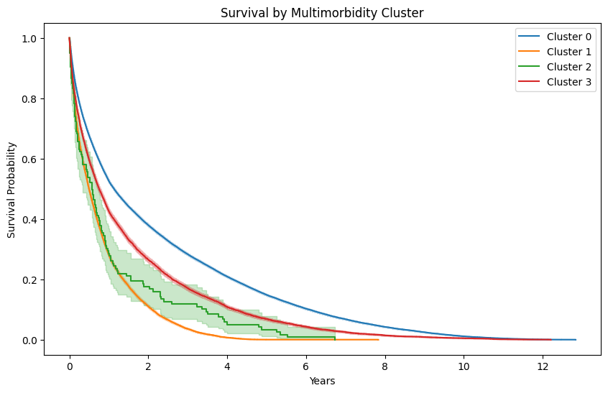
- Survival Analysis
- Kaplan-Meier curves demonstrated statistically significant differences in survival between clusters (log-rank p < 0.001)
- Highest-risk cluster: Cluster 1, with a median survival of 8 years, followed by Cluster 2 with 7.5 years.

- Cox proportional hazard model: The Concordance index is 0.6, which is suggestive of moderate predictive performance; clusters with higher multimorbidity are associated with increased mortality. Other significant predictors included age, creatinine, BUN, and heart failure.
Figure 4: Cox hazard ratios with 95% confidence intervals
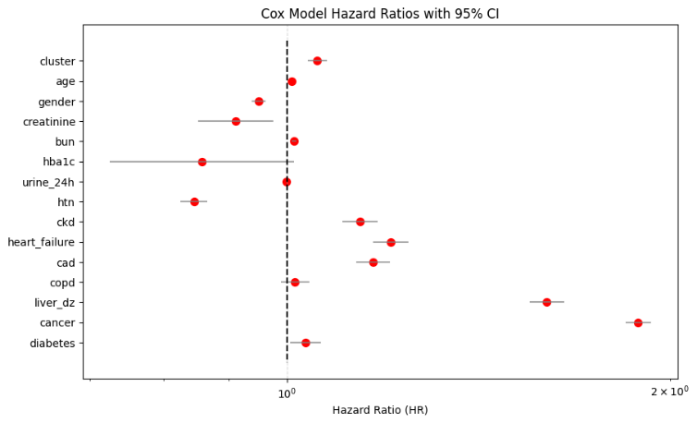

Figure 5: Cox hazard ratios with 95% confidence intervals for clusters
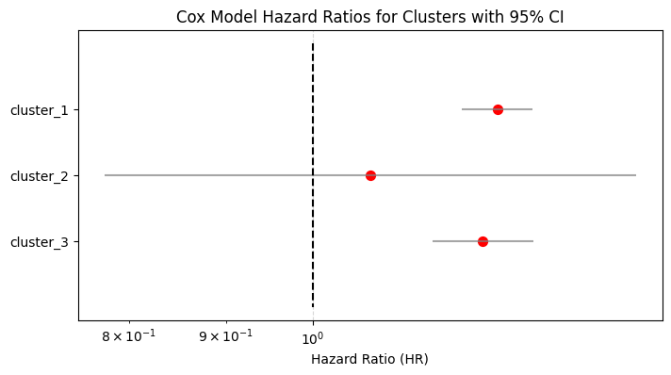
- Machine Learning Mortality Prediction
Model | Accuracy | Precision | Recall | F1-score | ROC-AUC
Random Forest | 0.65 | 0.39 | 0.76 | 0.52 | 0.76
XG Boost | 0.77 | 0.58 | 0.23 | 0.33 | 0.76
Top predictive features: age, cancer, creatinine, BUN and cluster membership
Figure 4: Random Forest feature importance
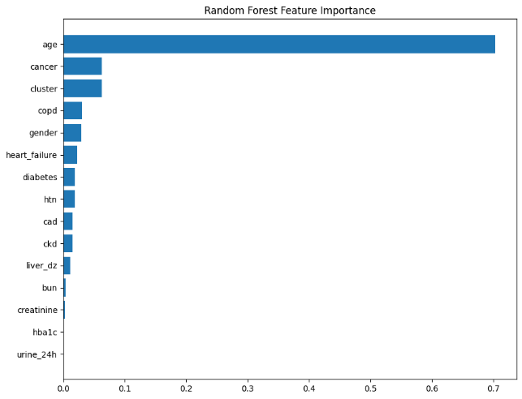
Figure 6: XG Boost feature importance
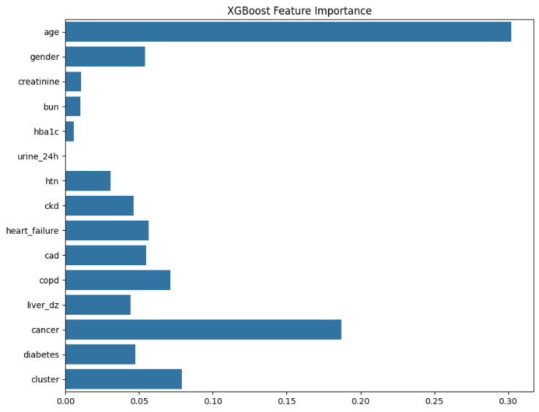
Top predictive features included age, creatinine, BUN, and cluster membership.

Discussion
- Multimorbidity clustering identifies clinically meaningful subgroups with distinct survival patterns.
- Cluster membership is a strong predictor of mortality, highlighting the importance of considering comorbidity combinations rather than individual diseases alone.
- Machine learning models using clusters and clinical features achieve high predictive performance, with interpretable feature importance highlighting renal function and age as key risk factors.
- Integration of clustering and Machine Learning can support risk stratification in hospital settings and guide resource allocation.

Limitations
- Missing laboratory or comorbidity data may introduce bias, despite imputation.
- K-means clustering assumes spherical clusters and may not capture all multimorbidity patterns.
- No external validation performed.

Future Work
- Incorporate longitudinal lab trajectories, medication data, and lifestyle data.
- Explore alternative clustering algorithms (e.g., hierarchical, DBSCAN) for multimorbidity.
- External validation in independent cohorts.

Conclusion
This study demonstrates that integrating multimorbidity clustering with machine learning meaningfully enhances risk stratification in ICU patients. By identifying patient subgroups with distinct survival patterns, such as those with metabolic multimorbidity or severe kidney dysfunction, we highlight high-risk clinical phenotypes that are often obscured by traditional single-disease models. These findings underscore the potential of data-driven approaches to support more personalized and precise care, enabling clinicians to tailor interventions based on cluster-specific risk.
The ability to incorporate cluster membership into predictive models and potentially into clinical decision-support systems offers a pathway toward real-time identification of patients who may require intensified monitoring, resource prioritization, or early palliative care involvement. Moreover, this work lays a foundation for future research examining causal mechanisms, treatment responses, and the prediction of downstream complications across multimorbidity clusters.
Overall, our findings show that multimorbidity-informed models not only improve mortality prediction but also provide actionable insights that can advance personalized medicine in critical care settings.

Funding
No external funding

Conflicts of Interest
None declared.

Acknowledgements
We acknowledge the MIT Laboratory for Computational Physiology for maintaining the MIMIC database.

References
Bandyopadhyay, A., Albashayreh, A., Zeinali, N., Fan, W., & Gilbertson-White, S. (2024). Using real-world electronic health record data to predict the development of 12 cancer-related symptoms in the context of multimorbidity. JAMIA Open, 7(3), ooae082. https://doi.org/10.1093/jamiaopen/ooae082
Pasea, L., Dashtban, A., Mizani, M., Bhuva, A., Morris, T., Mamza, J. B., & Banerjee, A. (2023). Risk factors, outcomes and healthcare utilisation in individuals with multimorbidity including heart failure, chronic kidney disease and type 2 diabetes mellitus: A national electronic health record study. Open Heart, 10(2). https://doi.org/10.1136/openhrt-2023-002332
Prigge, R., Fleetwood, K. J., Jackson, C. A., Mercer, S. W., Kelly, P. A., Sudlow, C., Norrie, J. D., Morales, D. R., Smith, D. J., & Guthrie, B. (2025). Robustly measuring multimorbidity using disparate linked datasets. Communications Medicine, 5(1), 283. https://doi.org/10.1038/s43856-025-00995-4
Williams, T. B., Garza, M., Lipchitz, R., Powell, T., Baghal, A., Swindle, T., & Sexton, K. W. (2022). Cultivating informatics capacity for multimorbidity: A learning health systems use case. Journal of Multimorbidity and Comorbidity, 12, 26335565221122017. https://doi.org/10.1177/26335565221122017

